02.NUTRITION IN LIVING ORGANISM – ANIMALS AND MAN

- Digestion - it is a process by which animals break down complex food substances in simpler substances.

Digestion in Humans
- The food that we eat passes through a Canal inside our body.
- The food is processed and utilized in the body and unused food is collected inside the canal only.
- This Canal is often called as the Alimentary Canal or the Digestive Tract.
- The canal is divided into different parts:
  - The Mouth or Buccal Cavity
  - Food Pipe or Oesophagus
  - Stomach
  - Small Intestine
  - Large Intestine
  - Anus
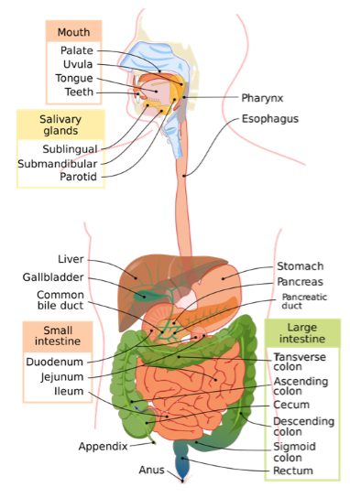
Figure 2: Digestive Tract in Humans
There are three glands associated with the alimentary canal that secrete digestive juices that are used to convert the complex food substances into simpler substances.
- liver
- pancreas
- salivary glands
The Digestive System - The alimentary canal and the digestive glands together form a system in the human body which is responsible for the digestion of food in the body. This system is called the Digestive System.

The Mouth or Buccal Cavity
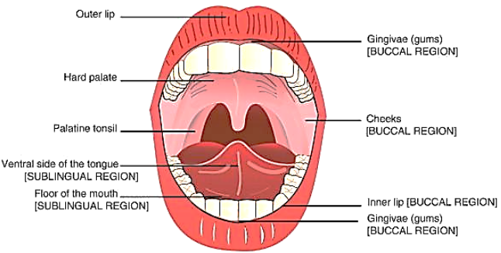
Figure 3: The Mouth or Buccal Cavity
- Ingestion - the process of taking in the food through the mouth is called ingestion.
- The food is chewed with the help of teeth, saliva and the tongue present in the mouth.
- The salivary glands present in our mouth secrete saliva which mixes with the food, moist it and breaks the starch present in the food into sugar.
- The tongue present in the mouth helps in mixing the food with the saliva and helps in swallowing it inside the mouth. It also has taste buds which help in identifying the taste of anything that we eat. Besides this, the tongue also helps in talking.
The Teeth
Milk Teeth - In the early childhood a set of teeth growth in children that then fall off after certain age 6 to 8 years. These teeth are called Milk Teeth.
Permanent Teeth - The teeth that grow after milk teeth fall off are called Permanent Teeth. They generally remain during the lifetime of a person or at least until old age.
Different Types of Teeth
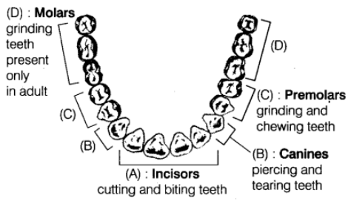
Figure 4: Different types of teeth
Tooth Decay –
- A gradual damage of teeth is often called tooth decay.
- The main cause of tooth decay is the presence of bacteria in the mouth that grow if we do not keep our mouth and teeth clean.
- Any leftover food present inside our teeth is broken down by such bacteria.
- As a result, an acid is released which damages the teeth slowly.
- Tooth decay can cause severe pain and even toothless.
- Tooth decay is caused mainly because of eating food with high sugar content, soft drinks and chocolates.
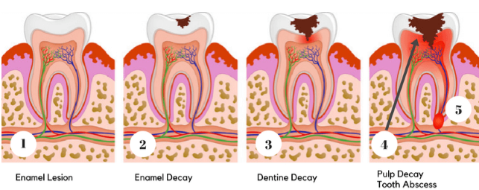
Figure 5: Stages of Tooth Decay
How can we prevent tooth decay?
- Clean your teeth with a brush or dental floss at least twice a day
- Rinse your mouth after every meal you eat
- Do not put a dirty finger or any unwashed food items in your mouth

Food Pipe or Oesophagus
- The food pipe starts from the neck region and runs until the chest area in animals.
- The food, when the chewed, moves through the food pipe and reach the stomach through this path.
- The food moves in download direction in the food pipe.

The Stomach
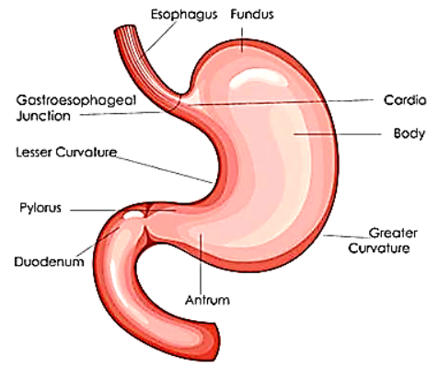
Figure 6: Stomach
- It is the widest part of the alimentary canal.
- It's a bag like structure in a flat U shape.
- The stomach is connected with the food pipe and the small intestine.
- The stomach’s inner lining produces three things:
  - Mucous: It protects the stomach lining
  - Hydrochloric Acid: It kills the bacteria present inside the stomach and activates the digestive juices
  - Digestive Juices: They help in digestion of the food by breaking down the proteins present in the food into simple substances (olympiads)

Small Intestine
- It is a highly coiled structure.
- The length of the small intestine is almost 7.5m.
- The liver and pancreas release digestive juices into the small intestine.
- The inner lining of the intestine also secretes some digestive juices on its own.
- The small intestine breaks the carbohydrates into glucose, fats into fatty acids and proteins into amino acids.
The Liver
- It is a gland reddish brown in colour.
- It is known as the largest gland of the human body.
- It secretes a digestive juice called bile juice.
- The bile juice is stored in the gallbladder.
- The bile juice makes it possible for the body to digest the fats.
The Pancreas
- It is a cream coloured gland present in the human body.
- It secretes pancreatic juice that helps in digestion of fats, carbohydrates and proteins.
How small intestine absorbs food?
- Absorption: it is a process by which the digested food enters the blood vessels of the small intestine.
- Villi in the intestine: the small intestine contains small finger-like structures called Villi. They increase the surface area of the intestine thereby increasing the amount of absorption. The digested food gets into the blood vessels through villi and then reaches the whole body. (Olympiads)
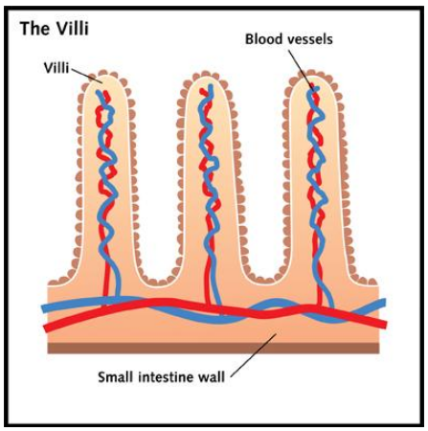
Figure 7: Villi in Small Intestine
- Assimilation: The process by which the organs of the body utilize the digested food and form complex substances which the body needs such as proteins are called Assimilation.
Parts of Small Intestine
The small intestine has been divided into three parts:
1. Duodenum
It is the first part of the small intestine whose main function is to initiate the digestive process. In this process, the food that enters the small intestine from the stomach is mixed with the digestive juices (bile and pancreatic juice) and is further broken down into simpler substances.
2. Jejunum
It is the middle part of the small intestine that contains the villi and hence undergoes absorption and assimilation.
3. Ileum
It is the third and last part of the small intestine that contains villi-like structures. The ileum absorbs vitamin B12, bile acids and any other nutrients present in the food.

The Large Intestine
- Any food that is left undigested passes through the small intestine and enters the large intestine.
- It is a wide tube-like structure.
- It is only 1.5 m long.
- The main function of the large intestine is to absorb water and salts from the undigested food.
- The rest of the waste, undigested food passes through the rectum.
- Egestion: The process by which the waste, undigested food (the faecal matter) get out of the body through the anus.
What is diarrhoea?
- A condition when watery stools appear frequently is called Diarrhoea.
- Food poisoning and infection are two main causes of diarrhoea.
- It is a serious disease and can lead to death in severe cases because it involves extensive loss of water and salts from the body.
- Generally, ORS (Oral Rehydration Solution) which is boiled cooled water in which a pinch of salt or sugar is added is recommended to the patients to maintain the water loss of the body.
Digestion in Grass Eating Animals
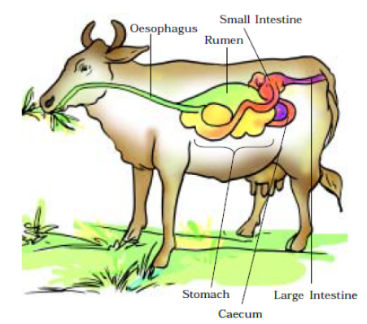
Figure 8: Digestive System in Cow
- Rumen - It is a sac-like structure present between the food pipe and the small intestine in grass eating animals like cows and buffaloes.
- At first, the animals do not chew their food (basically grass) and instead swallow it.
- This partly digested food is stored in the rumen.
- Cud: The partly digested food present in the rumen is called Cud.
- Rumination: The cud returns to the mouth in these animals and then they chew it. This is called Rumination.
- Ruminants: the animals that swallow their food at first and then chew it, later on, are called Ruminants.
- Grass eating animals can digest cellulose while several other animals cannot. These animals have a different type of bacteria present in the stomach that helps in digesting the cellulose. (Olympiads)

Feeding and Digestion in Amoeba
- The Amoeba is a microscopic organism which is made up of only one cell
- The Amoeba has a cell membrane, cytoplasm, a nucleus which is round and dense and small vacuoles which are like bubbles present all over it.
- The Amoeba is capable of changing its shape and position on its own.
- It uses false teeth called pseudopodia to take in the food present in the surroundings.
- Whenever it wants to intake the food the pseudopodia or finger-like projections come out of its body.
- The pseudopodia engulf the food in and the food gets stored in the food vacuoles.
- Then it secretes some digestive juices inside the vacuoles that help in its digestion of the food.
- The Amoeba then absorbs the digested food and uses it for fulfilling different life processes such as multiplication and growth.
- The Amoeba also secretes out waste products or undigested food out of its body. (Olympiads)
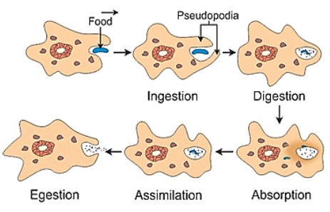
Figure 9: How amoeba digests the food

